AMAN PUBLIC CHARITABLE TRUST

NEW DELHI

Annual Report - 2020 to 2021

T-29, Ground Floor/Basement
Green Park Main
New Delhi – 110016, India
Telephone: +91-11 41328040-41
Website: www.amanpanchayat.org

Aman Public Charitable Trust, New Delhi

Annual Report
April 2020 – March 2021
An Overview
AMAN TRUST was founded in year 2001, projects are implemented in the domain of education, livelihood, gender justice and health and have contributed to the socio-economic transformation of marginalized communities in Uttar Pradesh and West Bengal states in India. Adhering to its commitment to gender justice and inclusivity, AMAN facilitated capacity development workshops, training, community dialogues and regional publication benefiting women and youth groups to promote their rights as well as advocate for the sexual minorities. AMAN timely updated its official website to improve organization's communication strategy and maintain transparency with its stakeholders and donors.Reviewing programme strategy and organigram were some key administrative initiatives at AMAN that enhanced programme effectiveness.
AMAN remains committed to the building of a just and compassionate society through its projects in the field of social and economic development along with campaigns and advocacy initiatives.
Our Projects
Education
In the backdrop of immense loss caused by the pandemic to education of underprivileged, educational initiatives were revised to reach out to the underserved populations. Vulnerable youth who are often stereotyped in their society were encouraged to experience and develop leadership skills.Their proactive participation in range of community-based activities enabled rebuilding of their role as key contributors in community development. Skilled youths were encouraged to use their learnings for further educating children in their network. Besides, marginalized communities in urban spaces like: city carriers, rag pickers, domestic workers, and construction workers were made aware about their educational and fundamentalrights. Through community centres and elementary schools, AMAN’s projects engaged in Milkipur, Masodha block of Ayodhya district and ten urban areas of Ayodhya Municipal Corporation.

Apna Taleem Ghar: Through community-based learning center children, their caregivers and other community members were occasionally brought together for informal knowledge sharing through creative means such as:stories, games, heritage walks etc. The initiative offered a safe learning space to children and enhanced community’s understanding to create an enabling environment for their children.

Bachpan Ke Rang: 20 primary school students were given the task of drawing and interpreting their art to develop their talent for arts and crafts and in co-curricular activities. Through this intervention the children were facilitated to express themselves through artistic work.

Education Messengers: Students of Avadh University, School of Social Work who are already under social work practice training were capacitated as volunteers who undertook teaching tasks in marginalized schools and organization’s community-based centers.The initiative empowered establishing a network between the literate youth and the underprivileged community at the grassroots.

Children's Library: A library was established for the students to enhance their learning experience by offering range of books beside classroom teaching. The target group of children have developed interest in reading and are able to experience improved learning outcomes.

Adolescent Education Conference: For facilitating a conducive socio-cultural environment for adolescent girls to attain formal education, a Kishori Shiksha Sammelan (community dialogue) was organised to identify and address the challenges faced by school going adolescent girls in their community across several region of intervention. Representatives from various schools, professor of degree college, youth leaders and representatives of community-based organizations participated in the dialogue session and shared strategies for maintaining a supportive school environment to enhance educational development of adolescent girls. As on outcome, the teacher’s collective decidedto launch series ofdialogue magazines forbetter awareness within the school community.The deputy Superintendent of Police (SP), Ayodhya was a distinguished guest at this event. At the end of the event a commitment letter was signed by threegovernment school teachers, threeprivate school teachers, five NGO leaders and the Deputy SP Ayodhya.

Community Development &Awareness
In Faizabad/Ayodhya district, 500 families who were severely impacted by the COVID-19 were offered trainings in survival skills. These families identified to be sustaining through - unorganised sector work, domestic work, and rag picking. Their poor economic situationgot exacerbated by the pandemic. Maintaining health and sanitation practices in their locality became another challenge due towaste water bodies, undeveloped waste management systems, and a lack of infrastructure for sewage plants. Thus, psychosocial support was offered to the target community’s youth and by ensuring their proactive involvement in their community’s development, various youth led awareness sessions and campaigns.The youth were provided with opportunities to positively engage with their community as well as gain acceptance by the larger society. The project separately assigned group tasks like - community cleaning drive, drainage cleaning, road maintenance, cleaning of water bodies and creating disposal system to 200 vulnerable families to ensure safe living environment.

Samantha ke Saathi:To address societal taboos and break stereotypical thought processes, 50 youths were encouraged tolead awareness raising sessions on – adolescent and youth health,body transformation, cross-gender friendships, family and youth’s role in family building, inter family relationships in society, family planning, challenges of adolescent girls, community development, and equality. Film screening followed by group discussions were organized to raise awareness on gender justice. Small group works aided strengthening of interpersonal relationships.

Avadh Theatre Group: Theatre workshops were organized at Little Hearts Academy for about 20 days. Two street plays, "Baat Ka Batangad" and "Kabira Khada Bazar Mai", were prepared and presentedcollectivelyby 35 students from different colleges.The plays intended toreinstate the values of humanity and raise understanding on the dire outcomes of violence.

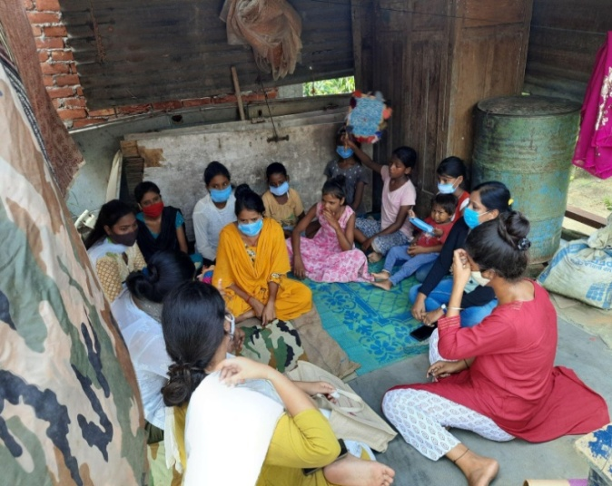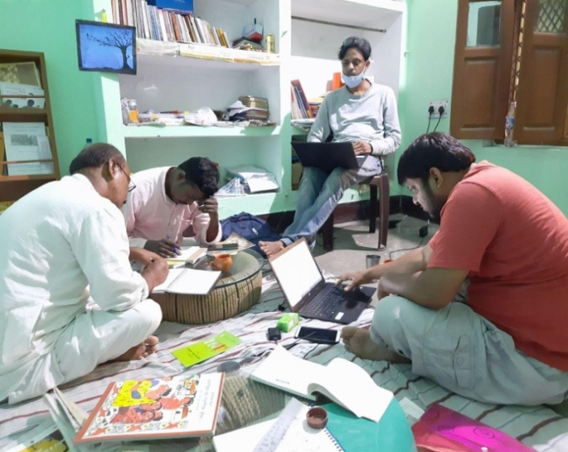

Gender Mainstreaming
In the state of West Bengal, Covid19 linked social distancing and lockdown severely impacted the gender minorities. Increasing social bias, discrimination, and injustice that sharply resurfaced were addressed through in-depth online discussions in Bengali. Girl children were assisted to recover from the psychosocial loss caused by the pandemic. A series of discussions were held on various consequence of the pandemic and lockdown on diverse groups of people in Indiathat enhanced community-level critical understanding. Digital resources were updated and released to ensure protection of gender minoritiesespecially during distressing times of pandemic.

Protecting school-going girls from pandemic’s aftermath: In Piyali village, Canning block of South 24 Parganas (West Bengal),small-scale educational support was offered to adolescent students whose family suffered severe socioeconomic loss post Amphan cyclone and then the prolonged pandemic. Awareness workshops, film screenings, therapy sessions and poster-making exercises were organized with the adolescent girls who remained deprived of safe space, classroom learning, online classes, cocurricular activities, peer’s support and teachers’ guidance. A crowdfunding venture was also initiated to offerfinancial support for fulfilment of educational needs of economically marginalized students. To bridge the digital learning gaps especially post pandemic, groundwork for launching a local library as community-based knowledge resource centre is initiated. Resource mobilization has begun to equip the library with books on a range of subjects, basic electronic devices, internet connection and other learning materials that will be used by adolescent students in a safe space.

Our Dialogue Series
Maath Kamre Bancha/ Women in Sports:An ‘audio-visual’10-episode interview series was conducted with support of Athletes’ Rights Activist Payoshni Mitra on issues related to women in sport. Ten exceptional women in sports were interviewed in this series: Footballer and coach Kuntala Ghosh Dastidar, sports journalist Sharda Ugra, wrestler Neetu, badminton champion and coach Madhumita Bisht, sport medicine specialist Dr Laila Das, para-athlete and activist Suvarna Raj, track athletes Dutee Chand and Jhuma Singh (Khatun), headmistress of Karanjali Girls’ School Rakhi Bhattacharya, and karate black belt Professor Supriya Chaudhuri. Theinterviewscovered important topics in the sports sector like- body issues, clothing, motherhood, minority representation, human rights, development through sport, and feminist connections in sport across generations. The series connected young aspiring athletes with more experienced women in sport.

Proposal for revising the legal age of marriage for women in India: To respond to increasing early age marriage during pandemic induced lockdown, an online discussion series was conducted onIndian government’s proposal to revise the legal age of marriage for Indian women. Several blogs and a debate piece featuring public opinion on the suitable age of marriage were released through social media handles.Adolescents from various district-level schools, along with school teachers, community workers, child rights activists, and several other stakeholders participated in these short videos and articles. This was followed by a national webinar discussing the Indian government’s proposal onwomen’s marriageable age. Representatives from organisations actively working with adolescent girls and women around education, early marriage, health and gender issues across the country participated in this webinar. Besides, the representatives from rights organization - Nirantarand Sama from Delhi;Talash and Praajak from Murshidabad and Malda districts of West Bengal shared their field experience and opinion on the proposed bill.

Equity, Digital Security, and Online Teaching: Three recurring webinars were conducted on equity, digital security, and online teaching, particularly involving school teachers, a majority of whom teach in government schools of West Bengal. The webinars were panelled by activists working on gender and technology, digital freedom, and security in relation to online teaching in schools during the lockdown.

Media & Sexual Harassment:An online discussion was organised with women journalists working across media houses and in different languages. The discussions focused on raising awareness on the rising cases of sexual harassment in media houses, the overall work culture, gender-based discrimination, and other relevant issues affecting women in media and journalism.

Our Digital Resources
‘Alape Gender’ Digital Archive: ‘Alape Gender’ (conversations on gender), an online archive of gender-related resources in Bengali, was launched to made all the dialogue sessions accessible on organization’s website and to raise awareness on the gender stereotyping. The digital archive records- the ‘Lockdown and Our Lives’ section featuring a collection of writings on the impact of lockdown on the lives of women and other marginalised groups; ‘Math Kamre Bancha’ (Women in Sports) featuring video-interviews with leading women in Indian sports; and ‘Bera Bhangar Golpo’ (Bodies and Barriers) featuring powerful stories of women who have been fighting against discrimination and inequality in sports at the international level. The archive has another section titled ‘8th March’ that traces the history and memories of the feminist and gender-equality movements in West Bengal.

Infographic Series: A number of digital infographics highlighting contemporary issues were released. In the first phase, three digital infographic series ‘Shobdo-Jobdo’ (definitions of different terms related to gender politics), ‘Asol Kotha’ (myths and facts), and ‘Ubacho’ (quotes from women who fought for different kinds of freedom) were released. In the second phase, ‘UbachoEkhan’ carrying quotes from women fighting against various forms of discrimination and injustice in the present times was released. In the third phase, ‘Kar Desh Kar Noy’ series was released that highlighted the Citizenship Amendment Bill (2019)related issues affecting different factions of marginalised communities including Muslims, women, sex workers, caste minorities, people with disabilities and others. Another set of 6-infographics was released carrying quotes of six young and fearless Indian women journalists fighting against discrimination in their workspaces.

Emergency Relief Response
Covid19 Mitigation: During Covid19 health emergency, health awareness workshops were organised that effected mindset change among thecommunities associated with AMAN’s project. Women and adolescent girls were assisted to adopt health practices for their overall wellbeing. To mitigate Covid19 related illness health desks were installed and supplied with first aid resources, menstrual hygiene products and Covid19 care kits (oximeter thermometer, pulse rate checking machine, blood pressure checking machine) in 10 communities of Ayodhya district(Faizabad).The initiative reached out to about 38000 community members including, 3400 adolescent girls (menstrual health) and 5000 women (reproductive health). PPE kits were distributed among the volunteers who managed the health desk. The volunteers ensured services to the grassroot communities.To contain Covid19 infection, the health desk ensured tele consultation with doctors, psychosocial counselling services, awareness generation on Covid19 appropriate behaviour, and keeping check on health status of persons in nearby communities. Health camps were organized for 6 months with the volunteering support of about 300 youths from the community.

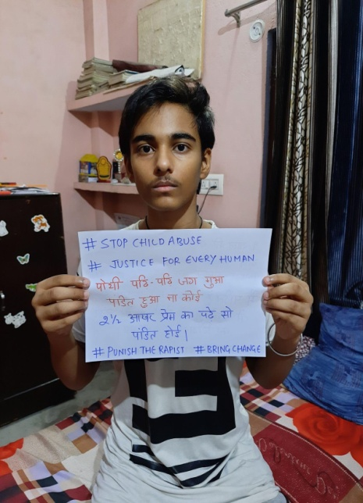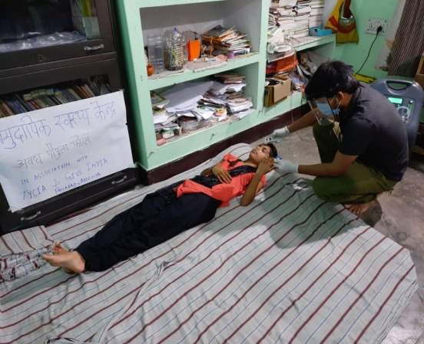

Relief Distribution: In 2021,dry ration wasdistributed among 200 families severely impacted by cyclone Yaas. Goonj and Karanjali Balika Vidyalaya in South 24 Parganas cooperated in assisting the relief distribution.

CONCLUSION
Building community-based network, raising awareness on gender inequality, and capacitating the youth from most marginalized communities for collective development and a dignified living have been the key achievements of AMAN in year 2020-21. Despite the challenges posed by the Covid19 pandemic, AMAN remained committed to reaching out to most vulnerable communities who were severely affected by pandemic’s aftermath. The digital way of operation enforced post pandemic led to strategizing online initiatives to reach out to the most marginalized whose situation became even distressing during Covid19 induced lockdown. AMAN’s commitment to its vision and mission has led to remarkable contributions in the field of gender justice, capacity development and advocacy in most underprivileged regions. We are grateful to all our generous donors and partners for their support. We also express our special gratitude to our project stakeholders for their assistance and, our colleagues who stood beside us through financial and moral support.

Jamal Kidwai, Director
Aman Public Charitable Trust, New Delhi

