AMAN PUBLIC CHARITABLE TRUST

NEW DELHI

Annual Report

April 2019 to March 2020

T-29, Ground Floor
Green Park Main
New Delhi – 110016
India
Telephone: +91-11 41328040-41
Website: www.amanpanchayat.org

Aman Public Charitable Trust, New Delhi
Annual Report
April 2019 – March 2020

An Overview
AMAN TRUST is glad to share its Annual Report for year 2019-20. With its philosophy based on ahimsa and samrastha (non-violence and harmony), AMAN was founded in year 2001 envisaging a proactive role for civil society in the reduction of communal conflict and mitigation of its effects. Building upon the years of experiences from field realities, AMAN’s projects strive to identify sources of social discontent and defuse tension through positive rebuilding of social conditions and relations aiming to promote peace in marginalized communities vulnerable to conflict.
AMAN was successful in implementing projects as per the proposed plans. As envisaged in its objective, AMAN continued community development projects in the domain of vocational training, livelihood and capacity development to support socio-economic transformation of marginalized communities in the state of Uttar Pradesh and West Bengal. The primary group of people we engaged with included about 5000 vulnerable women and youth and migrants. Adhering to its commitment to gender justice and inclusivity, AMAN facilitated capacity development workshops, trainings, community dialogues and regional publication benefiting women and youth groups to promote their rights as well as advocate for the sexual minorities.
To improve the organization’s communication strategy and maintain transparency with its stakeholders and donors, AMAN timely updated its official website with relevant information content.
Like each year, AMAN remains committed to the building of a just and compassionate society through its projects in the field of social and economic development coupled with campaigns and advocacy initiatives.

Our Projects
The Awadh People’s Forum
To promote leadership among youths, AMAN collaborated with Awadh People’s Forum (APF), Ayodhya, Faizabad to create learning platforms and pro-social grounds in community. The key interventions included health and skill development workshops for adolescents, capacity development workshops, and community dialogue sessions reinforcing social inclusion, advocacy and campaigns for encouraging realization of rights of children, youth, women and unorganized sector workers. The interventions aim to build peace and harmony in the community and to create sensitivity in youth towards environment, heritage, society and culture. AMAN - APF initiatives encourages youths to develop their way of living by engaging them in social interaction and by initiating struggle in inter-related communities.
This year the APF project introduced some grassroots programmes to address the community needs in current circumstances following group decision of its team members. A new Talim Ghar was setup for reaching out to the children living in Karam Ali Ka Purwa region. In the same region, APF acknowledged the struggles of women, domestic and construction workers who cope-up with their daily work load that affects their families living situations. Consequently, APF facilitated the formation of an organization that brought the unorganized workers together and connected them with the local labour department to enable them access government schemes. This was instrumental in improving our social relation with the community. This year we could reach out to 990 children, 350 youths and about 1000 construction workers.
The Educational Development Program focused on the wellbeing of garbage pickers, domestic workers, construction workers who do not have information on their basic rights and duties. The project successfully collaborated with many primary schools in and around the Faizabad city. A survey conducted to identify the number of dropout children assisted 46 children to get re-enrolled at primary schools in Paharganj, Naka, Ram Nagar and Modha. Our Education team has been working with these primary school teachers to support the development of re-enrolled children.

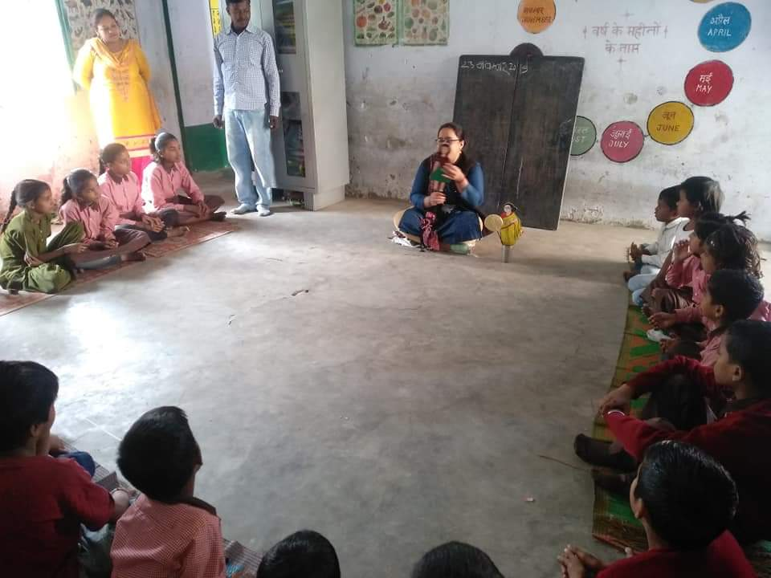
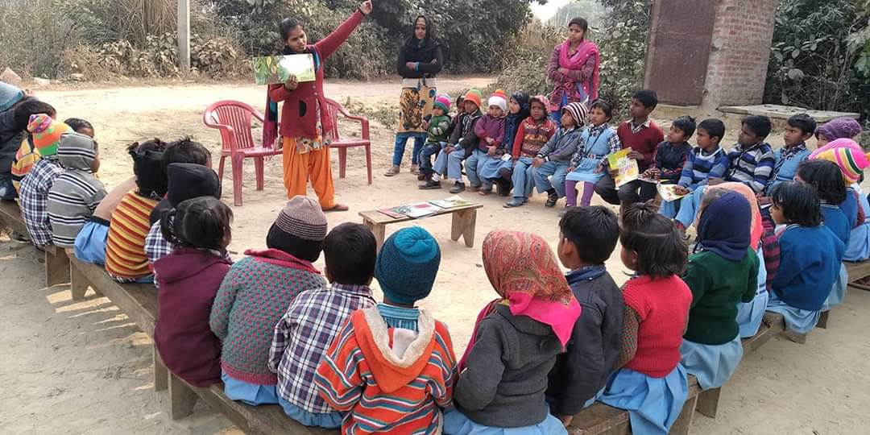
APF is supporting the renovation and sustenance of MM Lushkary Academy at Mehdauna, Braun Bazaar, Milkipur where five full-time classes for Grade nursery to 5th are conducted. Most of the students of this school belongs to families involved in beedi production.
Apna TalimGhar program successfully engaged children and created learning medium in their own environment through stories, games, heritage walk; most of the children associated with the Talim Ghar are now enrolled in primary schools.
In five districts of Awadh- Jounpur, Sultanpur, Ambedkar Nagar, Gonda and Faizabad, APF created an association of schools and its teachers – the Teacher’s resource & co-creation center. The program has generated awareness on societal history, language and social relations beside enhancing the teaching capacity in some subjects that are considered difficult. About 45 teachers who are also enrolled in graduation or post-graduation courses have now adopted inclusive teaching methods. Through collaborations, some teachers received training from centers such as - Judo gyan, Delhi; Vikramshila, Kolkata; Parag, Bhopal; NTT-Jingle Bell etc. Under the Bachpanke rang program we engaged with about 20 primary school children through several art and craft activities to develop co-curricular abilities of the students.
In one of the APF programme Space of education angel in educational schools, students of Awadh University, School of Social Work were trained on education procedures; a few other young volunteers from different colleges and communities also participated in this programme. The tasks given to these volunteers have enabled their understanding on school teaching. It has also established a harmonious relation between volunteering children and the community at the grassroots level.
To generate socio-cultural awareness and promote communal harmony, a Heritage Walk was organized for children and the teaching team which enlightened them about the shared culture and old association of Awadh at local level. Various events of historic and cultural importance were also commemorated at APF’s schools and centers which created a learning atmosphere in exciting ways. The students occasionally learnt about the biopic of freedom fighters and the importance of independence and republic day.
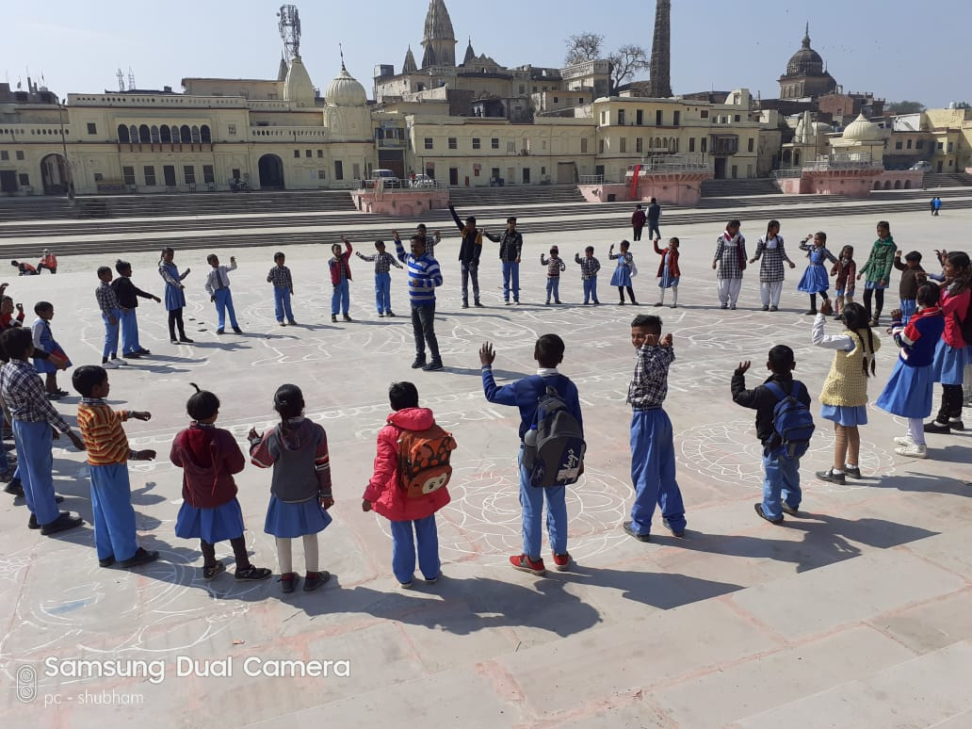
The Community Development Program provided counseling to marginalized youth for their mental health and employment needs. These youths were unemployed or typically engaged in minor day to day work. The program focused on mobilizing these youths in more productive and secure work to enhance their role in their community. Another program Samantake Sathi reached out to 50 youth through awareness raising activities to educate them on gender health, gender equality, positive friendship, girl-boy relationships, concept of family, youth’s role in family building and, the issues of adolescent girls in the family. Through Be a Jagrik program50 youth were sensitized on fundamental rights and duties through creative activities especially, rights that are important for youth’s development .School for Social Change – Youth Camp engaged with about three communities and educational institutions for conducting awareness campaigns in Krtania Forest, Shravasti bodh Vihar, Bewana Ambedkar, Tikri Forest Gonda. The camp provided opportunity to youth to be in a natural environment for about four days. Sessions on important topics such as gender, peace, culture and socio-cultural history were conducted at the camps.
APF introduced Awadh natya samooh this year under which theatre workshops were conducted for 20 days at Little Hearts Academy, Faizabad gaining participation of 35 youth from different colleges. Two street plays- “BAAT KA BATANGAD” & "KABIRA KHADA BAZAR MAI” were played to reinstate the value of humanity and non-violence.
- 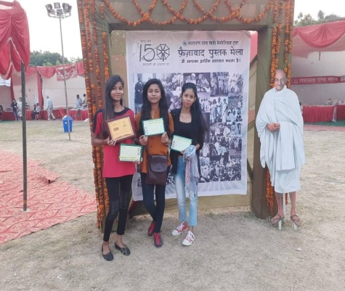.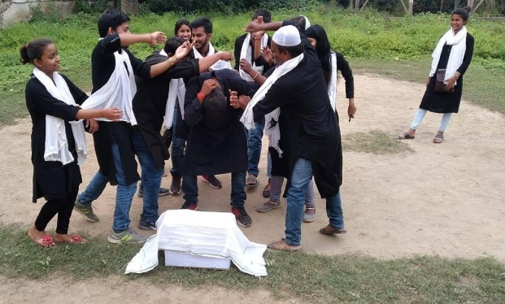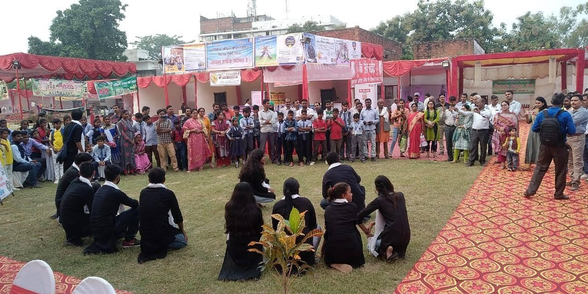
APF launched Prerna kishory vikaskendra for drop out girls who were enrolled in formal school for completing higher education. They were informed on menstrual health practices. About 300 teenagers have benefitted from this program whereas 20 girls received leadership training for leading and advocating for their community’s needs. Awadh Youth Collective have been formed in five districts - Gonda, Sultanpur, Jaunpur, Ambedkar nagar and Ayodhya of Awadh region which has encouraged social inclusion and educational development among youth with the support of Civil Society Organization who are working on youth issues.
APF has established a Manch of parents Parental Association: Family, Society and Construction involving participation of children and youth who are associated with APF programs. Regular meetings have been organized at the Manch on issues related to their children and social inclusion. SAHAR Fellowship Program was launched in partnership with Plus Trust (Samman janakhissedarikirahe) which benefitted vulnerable girls and women through financial support for duration of 6 months. 5 women who aspired to establish their small enterprise were supported under this programme.
Various campaigns involving neighboring cities were organized this year. The Gol Pe Bol program was conducted in collaboration with the Indian Foundation, Faizabad in the Awadh region. Through dialogues and discussions, the youth groups of the educational institution and the community carried out tasks with regard to the 17 points of the Sustainable Development Goal in their city. The campaign regularly engaged 50 youths to generate awareness on issues pertaining to education, health, gender equality, peace building, civil rights and encourage positive practices in their society. An 'Inclusion Youth Festival 2019' was organized where the District Youth Welfare Officer felicitated the youth participants for their efforts towards youth and community welfare.
The UP government initiated Kavach campaign in collaboration with UNICEF has raised awareness on girl child protection. In this campaign, APF has been the responsibility holder of organizing gender programs at the local level in Faizabad. Awareness program was organized in about 60 colleges and schools under the Girl Safety Program. Divisional level workshop was organized on 9 July 2019 at Awadh University, Faizabad on the topic of Girl Safety. In which, along with the DGP Faizabad, APF was given the organizing responsibility by the UNICEF.
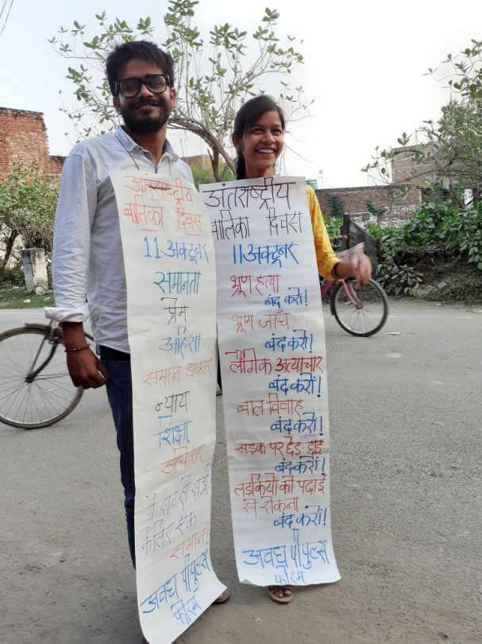
The 150th birth anniversary of Mahatma Gandhi was celebrated by Write a letter to Bapu initiative. The event called for honoring the great leader and his non-violent teachings. Under this campaign schools, colleges and communities came together to write on-line letters which were shared with APF.APF has planned to exhibit these letters during its awareness raising campaigns.
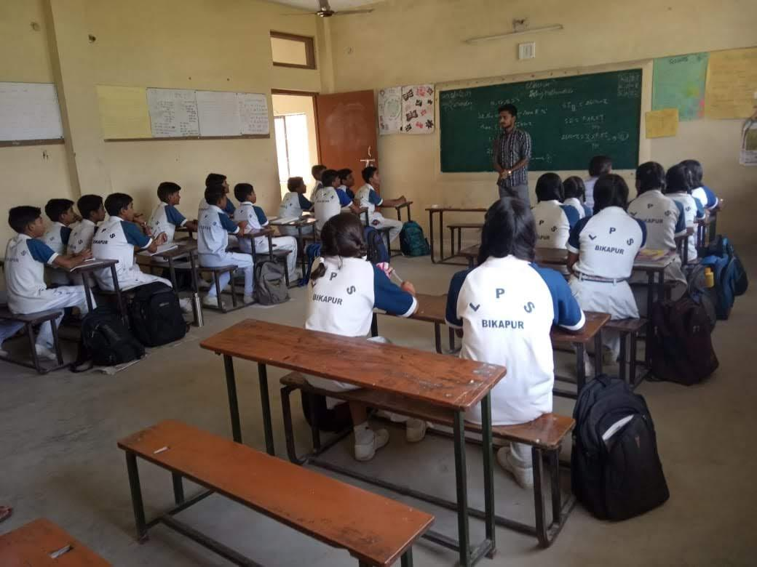
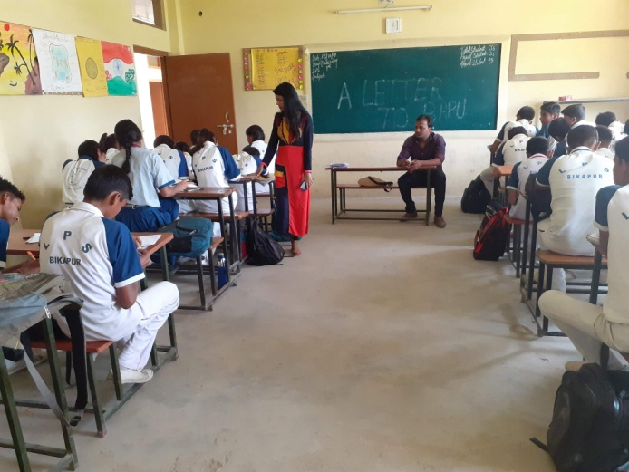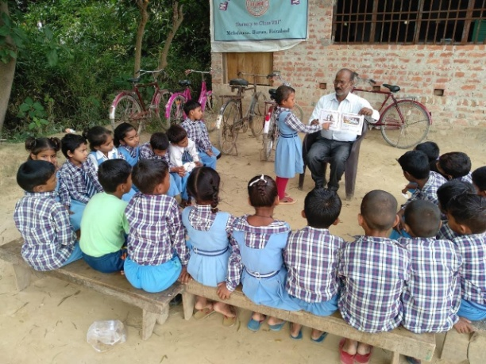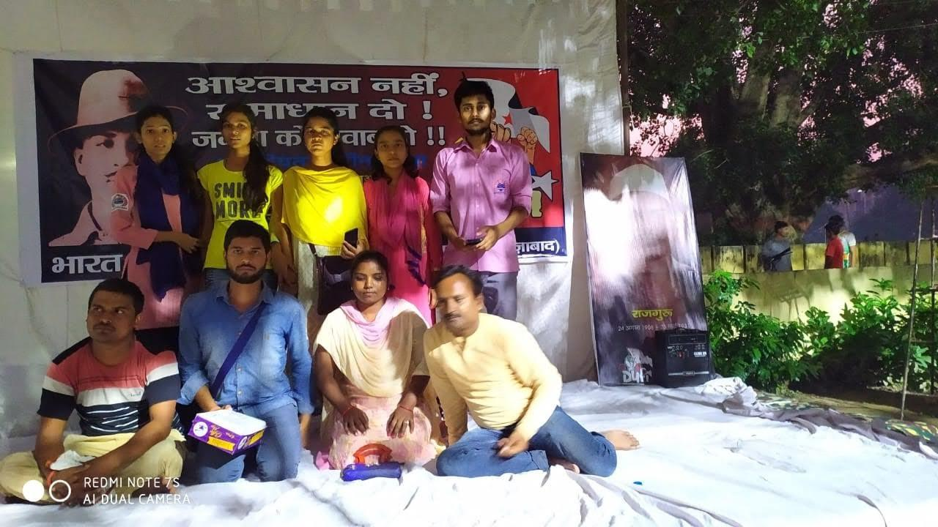
Act for scholarship campaign effort to connect deserving students with Government of India scholarship programs. Students were counseled to access the pre-matrix, post-matrix and matrix-cum-means scholarships for year 2019-20 sponsored by the Ministry of Minority Affairs, Government of India, to support students from minority communities in Ayodhya district.
Gender Campaign in the name of Avadh Youth Collective was created this year; a 16-day campaign against the gender violence was conducted in between November to December 2019. The campaign featured documentary films Man in Kitchen, Neighbor, The Think Beyond, Kat Bai I, Move On, O Bhai, Boy or Girl, etc. for stimulating gender dialogues among youth.
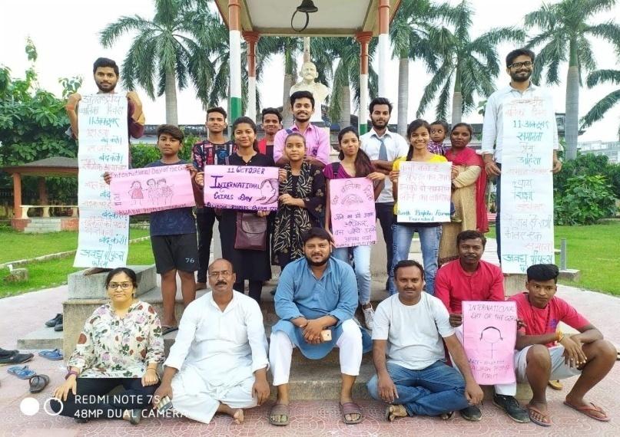
Samta Jagrukta Campaign focused on inclusive education by providing opportunities of better education to youth and children of weaker communities at formal education centers. The participation of the underprivileged community was encouraged at the existing educational institution and schools in the community by sensitizing youths to take lead in this action. Another special objective of this campaign was to create small collectives of youth at village level to address local problems especially, in the field of education. The campaign was carried outing 5 districts in collaboration with Oxfam India and other APF partners.
At the onset of COVID19 pandemic in March 2020, APF launched Rescue and Relief Operations by distributing masks and soaps at the local level among underprivileged communities. During the Janta Curfew which began 22ndMarch 2020, APF responded to humanitarian need of 10000 daily wage workers and laborers who lost their wage income by arranging dry rations.
Advocating for gender rights and rights of the sexual minorities
AMAN supported its local partner ‘Ebong Alap’ in facilitating various advocacy initiatives to protect the rights of women and sexual minorities’ especially in highly under-developed and remote area of Sunder ban, West Bengal. The project has contributed in improving target group’s access to knowledge and information about their rights and provided opportunities to conduct awareness raising discussions on gender, sexuality, gender-based violence, and sexual rights.
Ubacho, a poster exhibition was organized themed as In Her Own Words that amplified voices of women and their struggle for freedom in June 2019 at Gorky Sadan in Kolkata. Sensitizing posters with quotes and images of women were featured in this exhibition that recreated social and political histories in an innovative and informative manner.The content included word from women who participated in various freedom movements in colonial India. The participants gained knowledge on women’s participation in movements that demanded - freedom to read and write, freedom from caste oppression, freedom to work in their chosen fields and freedom from numerous other kinds of patriarchal and sectarian oppression. Eminent Bengali litterateur, writer and former civil servant and athlete who also happen to be among those women who were featured in the Ubacho posters were present as the guests of honor. Visitors from across city including school and college students, teachers, activists and media persons came to this week-long exhibition who participated in engaging comments and provided feedback. Again, Ebong Alap organized the first in a series of travelling exhibitions of Ubacho posters on trailblazing women hidden from history. Ramakrishna Sarada Mission Vivekananda Vidyabhavan, Dumdum, hosted this exhibition on 18 February, 2020. About 200 college students across departments participated in an interactive session post exhibition. The second exhibition was held on 7th March 2020 in Kanaknagar S D Institution, Hingalganj, followed by an interactive session with high school students around the posters.
Ebong Alap Lingo Samyo Samman awards2019 included four outstanding endeavors who fought stereotype and discrimination on the basis of gender. The awardees are - two individuals Lipika Biswas and Bilkis Bibi and, two institutions Laskarpur High School and Vivekananda College for Women. Liplike is a cyclist and explorer from Kolkata who is also the first Indian woman to do a solo cycling expedition across Europe. Whereas Bilk is, who is also from Kolkata, has strived to gain empowerment by walking away from a life of prolonged social and domestic oppression and chose the male-dominated field of cab driving as her profession. Vivekananda College for Women were honored for their very unique endeavor 'Prays' where the college arranged mid-day meals for students from underprivileged families who come to attend classes from distant areas in the outskirts of Kolkata and South 24 Paraganas. Laskarpur High School of Murshidabad was acknowledged for their outstanding work for prevention of early marriage of girls before the age of 18.
Ebong Alap initiative won the Social Media for Empowerment awards 2019 for Echo Alap under the 'Blogging, Vlogging, Storytelling' category on 2 August, 2019. The award is felicitated by the Digital Empowerment Foundation (DEF), an organization engaging on issues to dissolve the digital divide between rural and urban communities across India and South Asia. Through the award, Ebong Alap got an opportunity to present its work, vision, reach and engagements on social media platforms like Facebook, Twitter, Instagram and Whatsapp and the overall impact of Ebong Alap’s blog on Bengali reading in social media.
Ebong Alap's new book 'Sahaj AlapeyIshkuley Gender' on gender in school spaces was launched by the Chairperson of Textbook Committee, Govt. of West Bengal and the Chairperson of West Bengal Commission for Protection of Child Rights on 3 February, 2020. A symposium was also organized with the school teachers and stakeholders of education system in the state generating awareness on gender sensitive schooling. Engaging discussions focused on biased contents of subject-specific textbooks, discrimination in school curriculum and allied topics. Teachers, members of Ebong Alap and other participants of the programme have come up with a draft plan of action that assists the modification of school syllabus to encourage gender responsive education.

CONCLUSION
The year 2019-20 has seen progress in terms of successfully concluding community engagement projects especially addressing the vulnerabilities of ultra-marginalized communities at risk of sheering radicalization. Some new initiatives introduced in Uttar Pradesh and West Bengal states were deemed necessary in present times. AMAN’s commitment to its vision and mission has led to remarkable contributions in the field of peace work, allied capacity development and advocacy in most underprivileged regions. We are highly grateful to all our generous donors and partners American Jewish World Service, Human Capability Foundation and Holdeen India Program; our beneficiaries for their cooperation, project stakeholders for their assistance and, our AMAN colleagues who stood by us through financial and moral support.

Jamal Kidwai, Director
Aman Public Charitable Trust, New Delhi

