AMAN PUBLIC CHARITABLE TRUST

NEW DELHI

Annual Report

April 2018 to March 2019

T-29, Ground Floor
Green Park Main
New Delhi – 110016
India
Telephone: +91-11 41328040-41
Website: www.amanpanchayat.org
Aman Public Charitable Trust, New Delhi
Annual Report
April 2018 – March 2019

An Overview
AMAN TRUST is pleased to present to you its Annual Report for the financial year 2018-19. With its philosophy based on ahimsa and samrastha (non-violence and harmony), AMAN was founded in year 2001 envisaging a proactive role for civil society in the reduction of communal conflict and mitigation of its effects. Building upon the years of experiences from field realities, AMAN’s projects strive to identify sources of social discontent and defuse tension through positive rebuilding of social conditions and relations aiming to promote peace in marginalized communities vulnerable to conflict.
AMAN successfully executed projects as per the proposed plans. With a vision to achieve its objective, AMAN continued community development projects in the domain of vocational training, livelihood and capacity development to support socio-economic transformation of marginalized communities in the state of Uttar Pradesh and West Bengal reaching out to about 2000 individuals primarily- the women and youths. Our Programs Manager was invited to an international training course at Uppsala University in Sweden. She had the opportunity to present AMAN’s work at the ‘International Training on Dialogue and Mediation’ co-conducted by the Department of Peace & Conflict Research (DPCR), Uppsala University and Dag Hammarskjöld Foundation at Uppsala University in Uppsala, Sweden. The participants and trainers’ group comprised of United Nation’s dignitaries, academicians and professionals engaged in peace and conflict work across globe.
The NASSCOM Foundation project- Indian Public Library Movement (IPLM) collaborated with AMAN and launched the IPLM in 9 districts across the state of Uttar Pradesh. Following its commitment to gender justice and inclusivity, AMAN facilitated capacity development workshops, trainings, community dialogues and regional publication benefiting women and youth groups to promote their rights and advocate for sexual minorities.
To step up organization’s communication with its stakeholders and supporting donors, AMAN timely updated its official website. The web content is designed to be user and information friendly for maintaining organization’s transparency.
AMAN Trust remains committed to the building of a just and compassionate society through its projects in the field of social and economic development coupled with campaigns and advocacy initiatives.

Our Projects
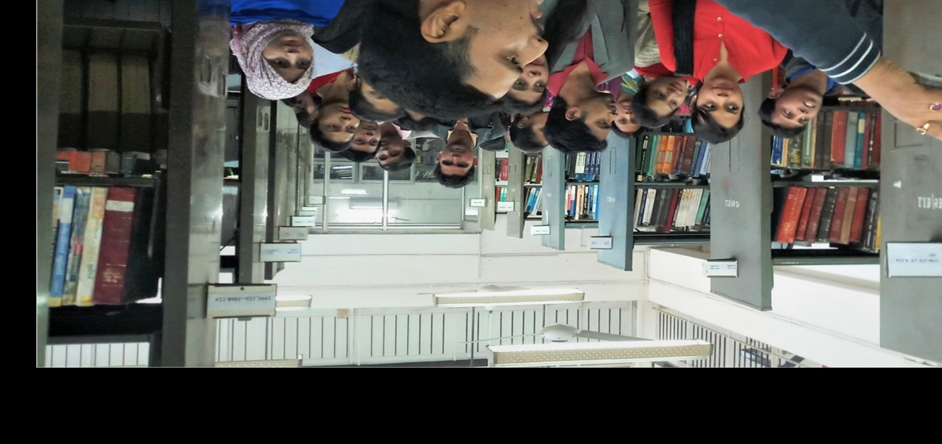
The Indian Public Library Movement (IPLM), Uttar Pradesh
The Indian Public Library Movement (IPLM) envisages transforming Government Public Libraries in partnership with the State government enhancing their role as catalyst of development. The project harnessed attempts to transform the public libraries in Uttar Pradesh into public spaces that serves more than a reading centers that is, a vital and vibrant community resource centers that provides easily accessible, relevant and updated information and skills to its users.
AMAN hosted the IPLM in Allahabad, Azamgarh, Etawah,Faizabad, Hardoi, Jhansi, Lucknow, Pratapgarh, and Varanasi districts of Uttar Pradesh. The project successfully gained participation of various stakeholders who are key role players in functioning of a public library. Main functionaries such as the librarians and the library support staff were offered capacity development trainings to equip them with knowledge and skills form an agingtheir library’s functioning. Further, various workshops, campaigns and user centered services were revived and introduced at the selected library to encourage public participation in utilization of library spaces. The participatory activities and services catered to the needs of several sections of society including- children, college students, youth looking at employment opportunities and training, young adults, women, researchers, senior citizens and general readers. As defined in its objective, the project ensured that the public libraries in the working districts work sustainably and effectively as independent public institutions providing value added services to the public. A rise in number of library membership over the project period was recorded; it increased by more than 50 percent, from 443 in the beginning of the project to 1177 towards its end. A National level seminar held by IPLM-UP in partnership with Ambedkar University in Lucknow brought together the project stakeholders and highlighted the challenges faced by the public libraries in Uttar Pradesh; a need to develop a library Charter was also proposed.
To ensure project’s sustainability, the IPLM-UP initiative has facilitated the formation and institutionalization processes of the District Library Committees (DLC) in 7 of the working districts and has encouraged them to conduct regular meetings. These meetings are to enable the effective functioning of the library under the leadership of the respective District Magistrates. The Committees ensure that the libraries functions independent institutions that respond to the local and contextual needs of the communities in their respective location.

Women Empowerment Programmes in UP
Promoting youths as leaders of tomorrow by through youth leadership programmes, AMAN collaborated with Awadh People’s Forum (APF), Ayodhya, Faizabad to create learning platforms in community, especially youth. The key interventions included capacity development workshops, community dialogue sessions reinforcing social inclusion, and campaigns for encouraging realization of rights of children, youth, women and unorganized sector workers.
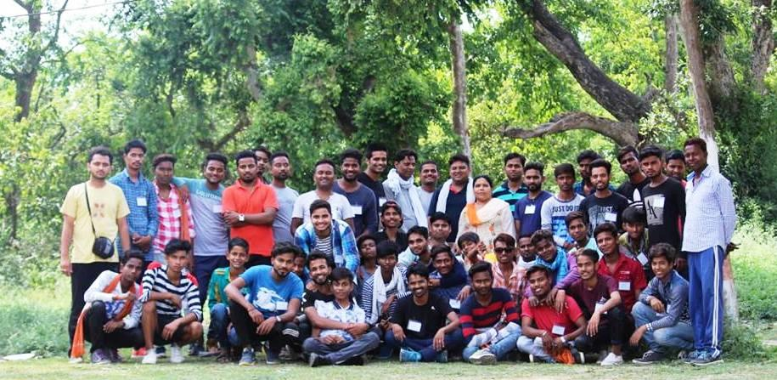
Samantake Sathi, a social inclusion project under the Youth Leadership Development Program connected about 150 new youths in 4 different regions of Faizabad city. Small dialogue programs on gender, caste, religion-based inequality were regularly organized with the youths to enable their positive participation in the community and transform their own future. Sahitya Lucknow organized a workshop in April 2018 focusing on Uttar Pradesh Youth Policy’s(2016) effective implementation. Various youth organizations/organizations of Uttar Pradesh were sensitized on youth policy through the workshop. 3‘Divas Youth Social Inclusion Camps’ were organized with 50 youth enabling participants to identify the strengths of socio-cultural diversity. Eid Milan-Rabta was organized at the Anees Chakabast Library in Faizabad, Ayodhya bringing together 40 people including the youth and people from other socio-cultural organizations of the city. The Delhi Young Artist Forum team were facilitated on their learning visit to Lucknow; a meeting with the Science Foundation's youth group and the girl beneficiaries of Sanatkada organization, Lucknow helped the youth to mutually learn about challenges of rehabilitation. Discussions on the youth’s access to learning platforms inside these settlements were helpful in highlighting some shared challenges related to learning opportunities among rehabilitating communities. Besides, a city tour to historical landmarks enabled their learning on the leaders of Bahujan Movement. The core and the main volunteer team of APF attended a workshop organized at the Journalism Training Institute learning about the tools for grass root reporting. #Shravasti Inclusion Youth Camp organized in January 2019 brought together various schools in Faizabad and the youth of the college and community to dialogue on issues of education, gender, inequality, communal harmony. The dialogue session especially focused on educating on topics such as- active citizenship, constitutional values, duties and rights of the youth.
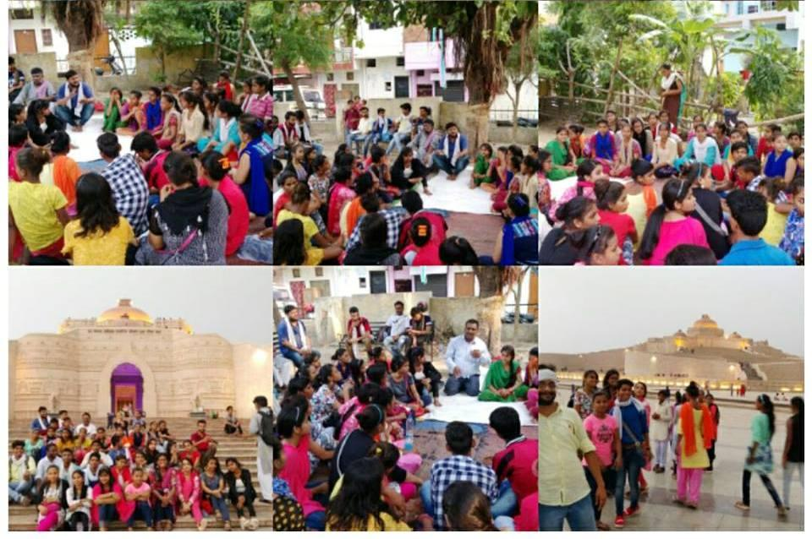
Under Apna TaleemGhar project attempts were made to develop the art of teaching and community-based learning centres in Paharganj and Tanda regions of Uttar Pradesh. About 150 children and youth are associated with these centres who often come together for community-based reading sessions under the leadership of 4 volunteer teachers. 50 teachers from Faizabad region who are part of Apna Taleem Gharwere associated with the Teacher Resource and Co-Creation Centre that enabled their learning on innovative teaching methods. Timely organized inclusive teaching workshops have catered to the learning needs of about 60 -70 teachers located in remote regions having limited access to self-development resources. Children's dialogue program was organized in Apna Taleem Ghar project community along with government/non-government schools that enabled about 600 children to participate in group learning exercises, art sessions and social cultural programmes in the project community.
Under Samudayvikas, Samuday kesath project APF expanded its operations and started the rural development program in Gram Panchayat Mehduna, Dobhiyara, Sarai; Harringtganj development blocks of Gram Panchayat Halla Dwarkikapur and Mukimpur in Milkipur Development Block. On 30 September 2018, Tanda's APF team connected the local health department with the community through an interface meeting for addressing the existing health concerns in the community. AMAN – APF also lobbied for the rights of the unorganized sector workers leading to efforts for mobilizing and registering domestic workers, shoe and construction workers in Faizabad region. In Tanda region of Ambedkar Nagar districts,20-25 young fellow weavers have started connecting with the Youth Forum at APF who are helping them to start weavers’ training center.
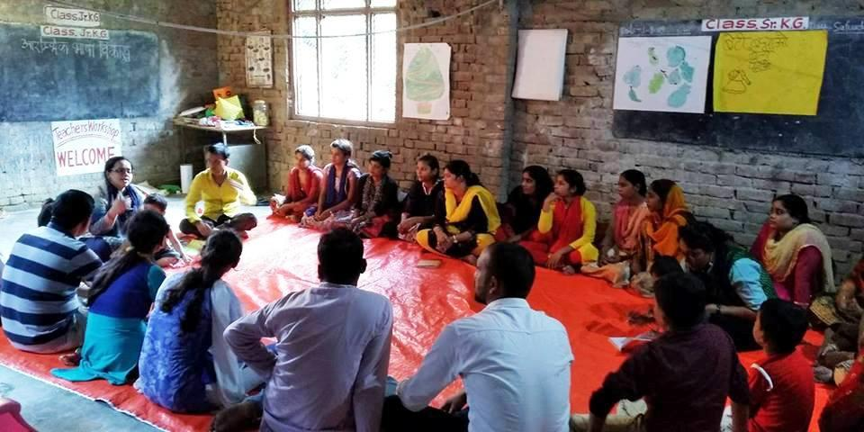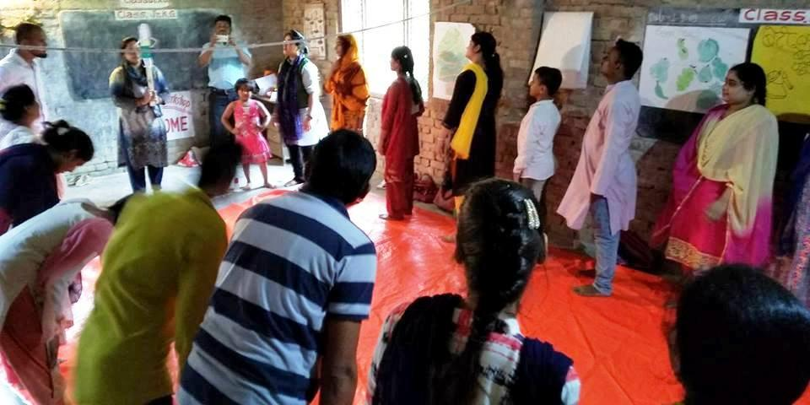
To enhance APF’s intervention, the Forum's Chief Partners have joined the Shruti Social Development School. Two APF members are enrolled in a 6-month course at Vikramshila-Kolkata to learn about effective classroom teaching skills for marginalized group of children. Another APF member is attending the Parag Library Learning Course who is already managing center in Tanda region. The course enables APF member to participate in workshops organized by Parag Library in Bhopal and impart skills to children for creating children centered library in school and community. The Jodo Gyan initiative capacitated APF colleagues to teach elementary mathematics efficiently aimed to motivate interest of children in school and APF apnea training house in subject specific learning. The course has also enabled connection between the APF colleagues located in different intervention regions.
The APF project has let to various partnerships to boost its impact and outreach. Organizations working on the issue of unorganized workers (including AMAN-APF initiative) in various districts of Uttar Pradesh joined the Mathadi Kamgar Rashtriya Sammelan. An APF member who is also an associate of the Kamgar movement of Maharashtra participated in this conference along with other 150 delegates from unions, public organizations, weavers, construction, fishermen, urban workers, women workers, domestic workers groups. In August 2018, various district organizations came together in the office of Janmorcha, Dainik newspaper Faizabad to strategize the "Baat Aman'' Yatra from Delhi to Bihar.
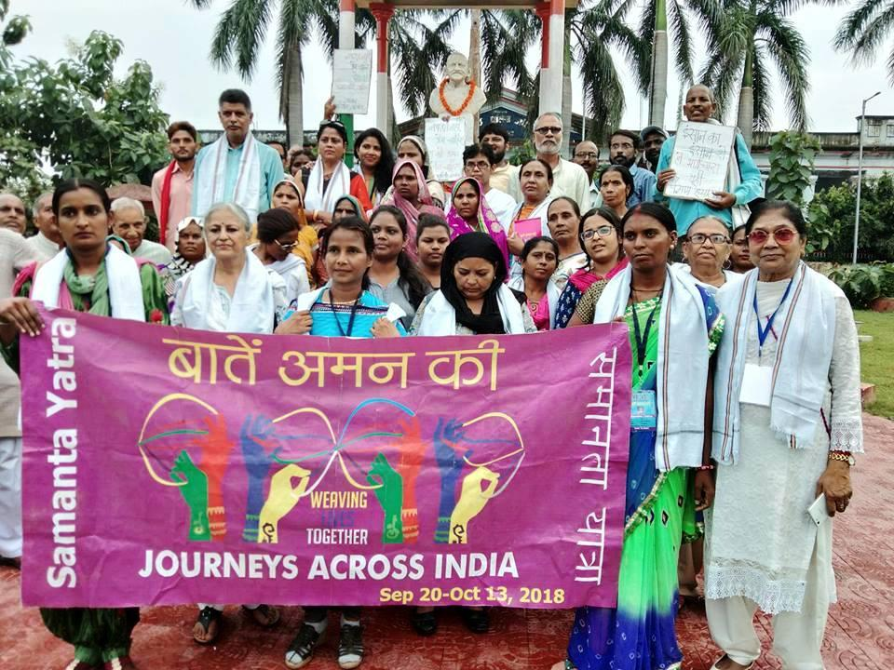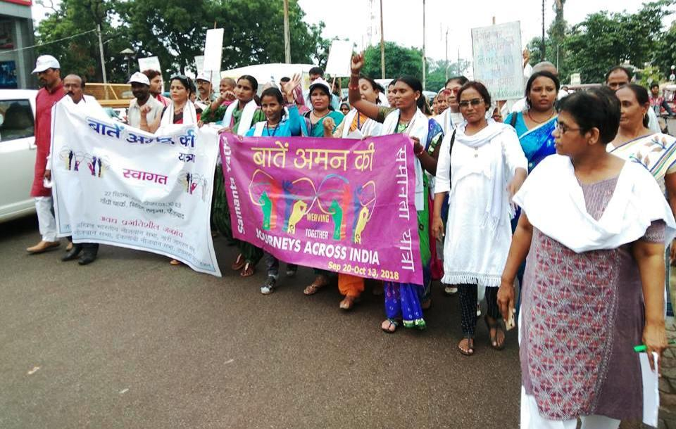
A 16-day gender-free fortnight was celebrated in Faizabad between 25 November and 10 December 2018 that screened a sensitizing film for the youth in educational institutions and community. The Student Internship Program was carried forward reaching out to about 8 colleges (in APF area of intervention) under the leadership of two full time APF Volunteers who are pursuing masters in social work from Avadh University assisted by 4 other part-time student volunteers from the Awadh University. Attempts were made to organize common efforts in the college campus that encouraged leadership abilities among youths from under privileged communities.
Advocating for the rights of gender and sexual minorities
AMAN supported its grass root partner ‘Ebong Alap’ in facilitating various advocacy initiatives to protect the rights of women and sexual minorities especially in highly under-developed and remote area of Sunder ban, West Bengal. The project is directed to improve their access to knowledge and information about rights and for creating a space for discussing gender, sexuality, gender-based violence, and sexual rights. To encourage participatory and Gender-sensitive citizenship, AMAN supported dialogues in the local language among variously marginalized youths at grassroots and in the educational institute. The projects also facilitated vital publications aiming to bridge information gaps and reduce the English-local language/ rural-urban divide in knowledge hierarchy pertaining to gender, sexuality, queer issues and their interface with key contemporary concerns.
On 11 May 2018, Ebong Alap collaborated with the ‘Gender Cell’ of the Medinipur College (Autonomous)to facilitate the third workshop under its yearlong gender sensitization programme. The workshop gained participation of 60 students who were informed about the gender perspective in history of women’s education in colonial Bengal. The participants were motivated to understand present day challenges of gender stereotypes operating in educational institutions that are reflected in syllabus and curricula of academic institutions.
Ebong Alap and Sundar ban Bijayanagar Disha co-conducted three inter- community dialogue workshops with women aiming to stimulate exchange of thoughts on their common hardships and perspectives. The participants were from three SGSY (Swarnjayanti Gram Swarozgar Yojana) groups in Bali Island, Sunder ban belonging to different religiouscommunities and castes. The interactive dialogue sessions aided participants to develop a sense of harmony among communities who are largely vulnerable to stirring radicalization. Monthly gender sessions were also conducted with the women’s group of Bali region in Sunderban. These sessions were participated by the CBO members along with a group of high school students who are being mentored as peer leaders by Ebong Alap.
The fortnight webzine ‘Ekhan Alap’, the only blog/webzine in Bangla, was regularly published. The publication encompassed issues on gender rights and has a readership across Bengal, Bangladesh, and other parts of India. The webzine is also honored by the ‘South Asia Laadli Media Award ‘in October 2018for attempting to raise concerns on gender sensitivity while bridging the knowledge gap between the urban and rural communities. Three digital info graphics series were also created in the local language and shared across social media. Shobdo-Jobdo (Crosswords) is a series that defines key words related to gender-sexuality; AsolKotha (Breaking Myths) debunks myths and gender stereotypes and Ubacho (She Said It) is made out of quotes from women trailblazers hidden from history.
CONCLUSION
The year 2018-19 witnessed progress in terms of successfully concluding previous projects. New grass root projects were introduced in this term that well compliments AMAN’s vision and mission. Contribution in the field of peace keeping and allied capacity development as well as advocacy efforts were upscale in this project period. We place on record our immense gratitude to all our generous donors and partners – NASSCOM Foundation, American Jewish World Service, Human Capability Foundation and Holdeen India Program; our beneficiaries for their cooperation, project stakeholders for their assistance and, our AMAN colleagues who stood by us through financial and moral support.
Jamal Kidwai, Director
Aman Public Charitable Trust, New Delhi

